

***A Mini-Project Report On***

**“Telegram Chat bot using NLP”**

***Submitted By***

**Anand Bang**

**Roll No: 104**

**Abhishek Chaudhari**

**Roll No: 108**

**Nikhil Jumde**

**Roll No: 124**

**Pranav Nagawade**

**Roll No: 137**

**Rakesh Amarjintha**

**Roll No:103**

**Vinit Gawli**

**Roll No: 117**

**S.Y. M.Sc. (Data Science and Big Data Analytics)**

**School of Computer Science**

**Faculty of Science**

**MIT – World Peace University**

**Pune - 411038**

**Academic Year 2020-2021**

**MAY – 2021**

**MIT WORLD PEACE UNIVERSITY, PUNE SCHOOL OF COMPUTER SCIENCE**

***Certificate***

This is to certify that

**Anand Bang**

**Roll no. 104**

Of ***M.Sc. (Data Science and Big Data Analytics)*** successfully completed his/her

Mini-Project in

### **“Telegram Chat bot using NLP”**

to our satisfaction and submitted the same during the academic year 2019- 2020 towards the partial fulfilment of degree of **Master of Science in Data Science and Big Data Analytics** of MIT World Peace University under the School of Computer Science, MIT WPU, Pune.

|  |  |  |
| --- | --- | --- |
| **Prof. Dr. Shubhalaxmi Joshi** | **Prof. Prajakta Soman** | **Prof. Surabhi Thatte** |
| **Associate Dean** | **Program Head** | **Assistant Professor** |
| **Faculty of Science** | **School of Computer Science** | **School of Computer Science** |
| **MITWPU** | **MIT WPU** | **MIT WPU** |

**ACKNOWLEDGEMENT**

In the accomplishment of this project I would like to express my special thanks of gratitude to my teacher Mrs. Prajakta Soman School of Computer Science, MIT World Peace University whose valuable guidance has been the ones that helped me patch this project and make it full proof success. Their suggestions and instructions have served as the major contributor towards the completion of the project.

As we were working in a group, I would like to thank my group members for their fabulous support throughout the completion of the project. We learnt a lot of things during this period as it were hard to work in this time of adversity; we were in touch with each other throughout the period and shared everything which was important from the aspect of our project. As this project was completed by staying at home I would also like to thank our families for their co-operation and for providing facilities to us.

Anand Bang

Roll No. 104

Contents

Introduction 5

Domain Name 5

Motivation 5

Problem Statement 5

Literature Survey 6

Solution Design 7

Solution Approach 7

Technology Stack 7

Design Model 7

Solution Implementation and Results 8

Obtaining Data 8

EDA 8

Pre-Processing 14

Algorithms Used 14

Results 16

Conclusion and Future Work 21

Conclusion 21

Future Work 21

References 22

# Introduction

**Problem statement:** Building a telegram chat bot that uses Deep Learning and NLP to solve queries and doubts of university students.

**Description of Problem Statement:** Colleges don’t have call centers for potential students to solve their queries. Colleges do have enquiry cell but it’s usually understaffed and some students call them up for doubts when answers to them are clearly given in the website. They keep the staff busy and the student with genuine issues has to wait in line until the staff solves other easy queries. To solve this problem we have built a telegram chatbot for students to solve their issues. If the bot is not able to solve their issues the bot will connect the user to the enquiry cell.

**Motivation:** We have seen that students fail read simple instructions on the website and then call the enquiry cell to ask doubts. To counter this problem we decided to automate this simple doubt solving process.

**Literature Survey:**

Pooja Raundale; Akash Sawale - Dialog prediction in Institute Admission: A Deep Learning Way.

Gokaran , Ayush - Development of Chatbot Using Deep NLP and Python.

**Solution Design**

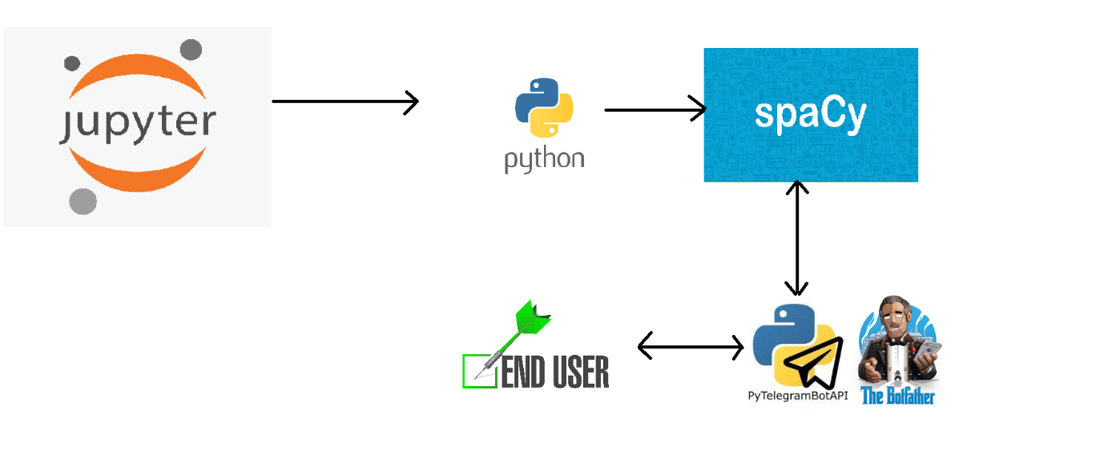

Technology Stack

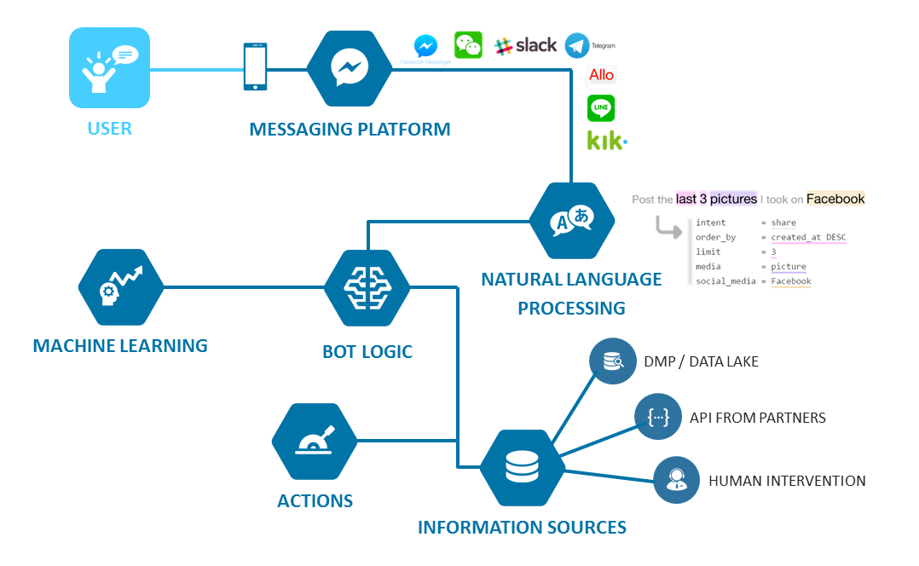

* **Telegram**

Telegram delivers messages faster than any other application. Powerful. Telegram has no limits on the size of your media and chats.

* **Python**

Python is an interpreted high-level general-purpose programming language.

* **JSON**

JSON (JavaScript Object Notation) is a lightweight data-interchange format. It is easy for humans to read and write.

* **NumPy**

NumPy offers comprehensive mathematical functions, random number generators, linear algebra routines, Fourier transforms, and more.

* **Spacy**

SpaCy is a free open-source library for Natural Language Processing in Python.

* **Jupyter**

Jupyter Notebook (formerly Python Notebooks) is a web-based interactive computational environment for creating notebook documents.

* **Telebot**

Telebot is a bot framework for Telegram Bot API. This package provides the best of its kind API for command routing, inline query requests and keyboards, as well as callbacks.

Design Model

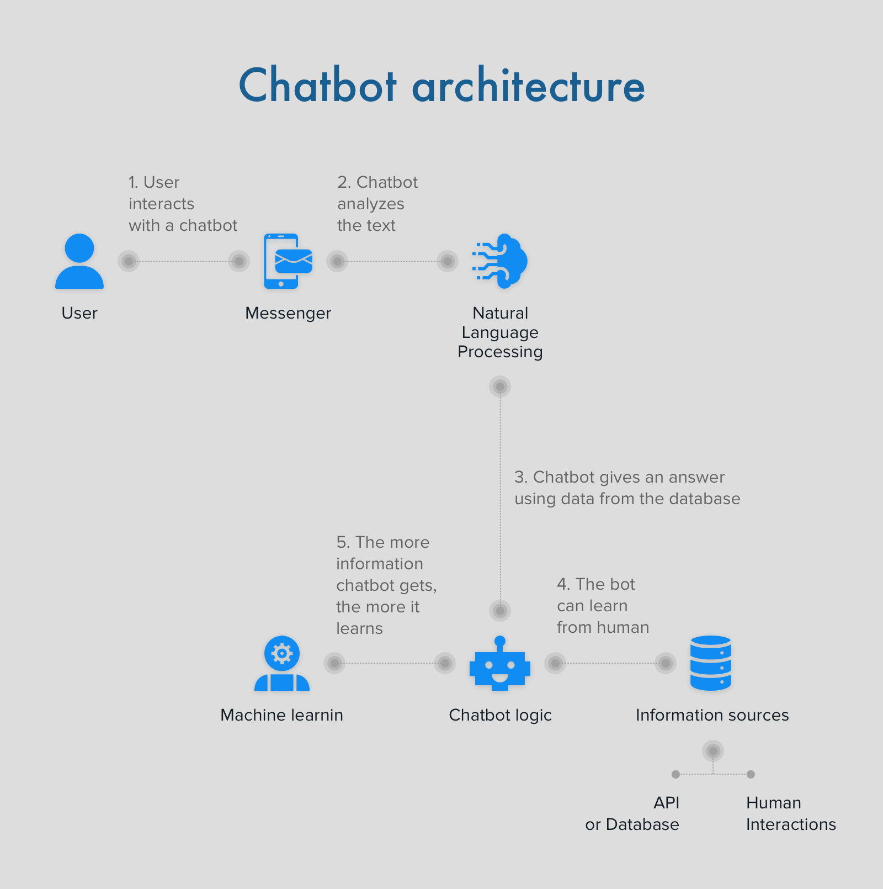

**SOLUTION IMPLEMENTATION**

**AND RESULTS**

The end user has to have a telegram account. In telegram the end user will search the name of the bot and to interact with the bot must press “start”. To get started the user can type “help” in order to know what kind of help or information the bot is able to provide. The bot also replies to greeting messages like “hi”, “hey” etc.

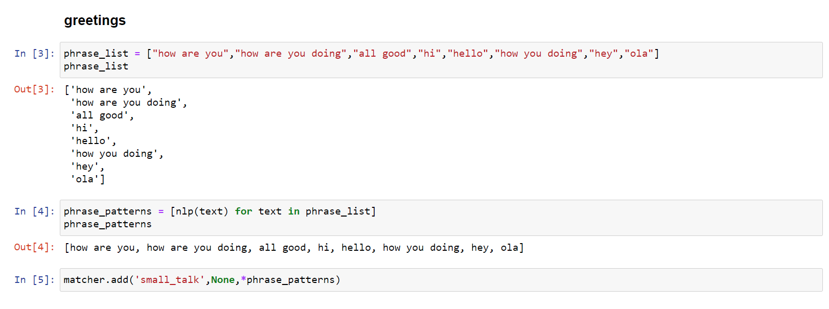

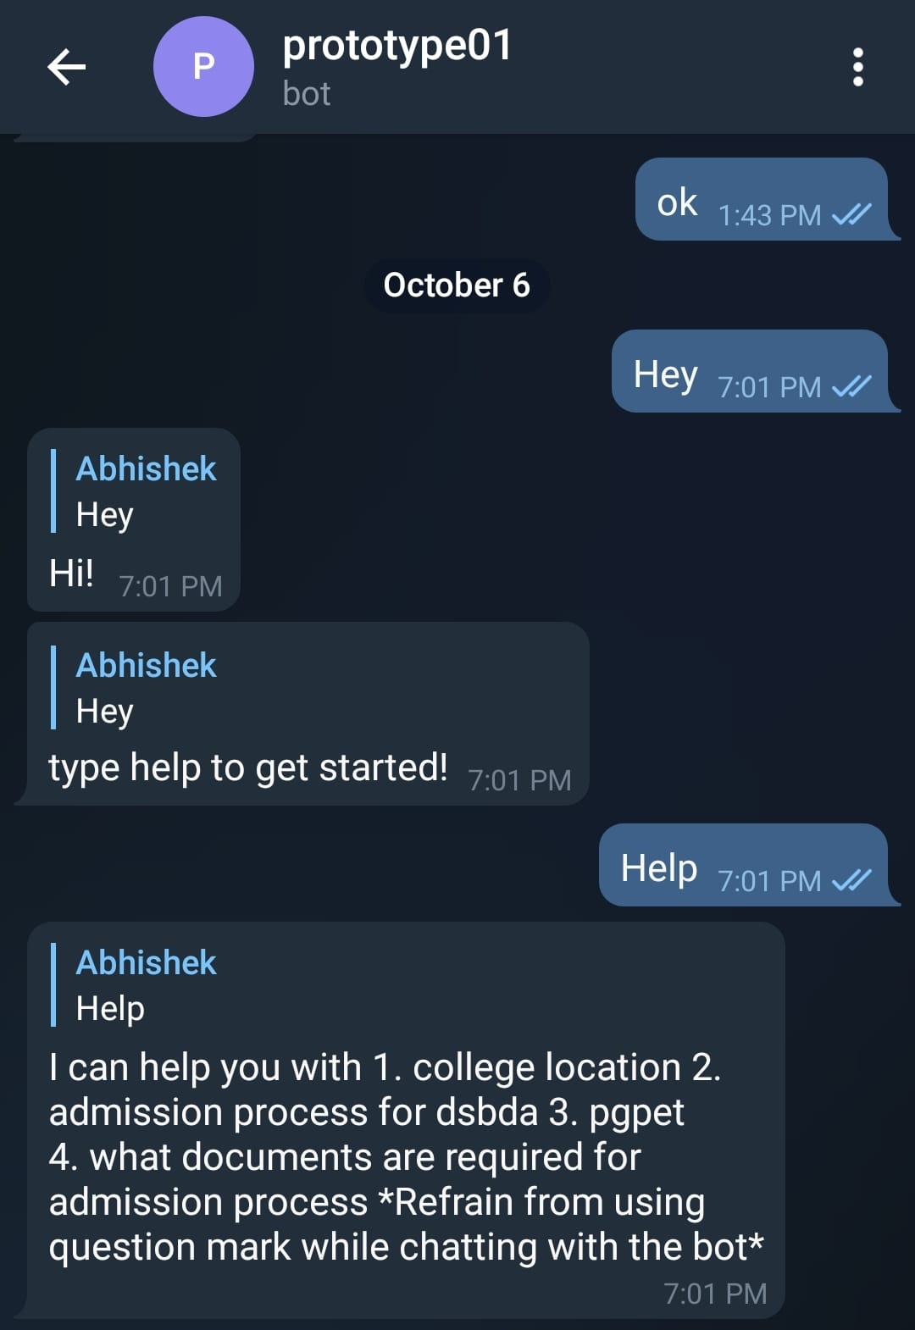

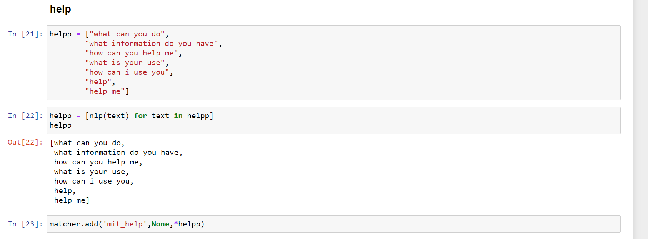

It can also handle basic enquires about our course.

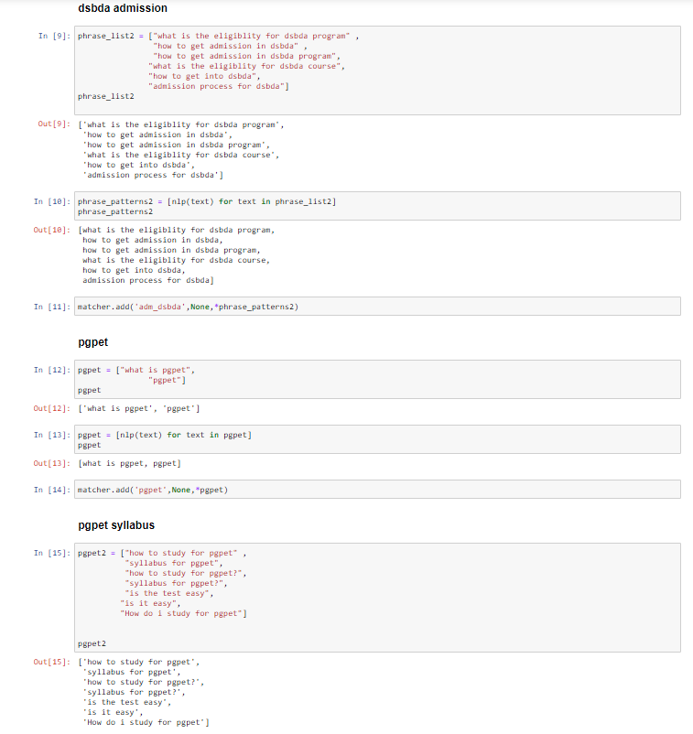

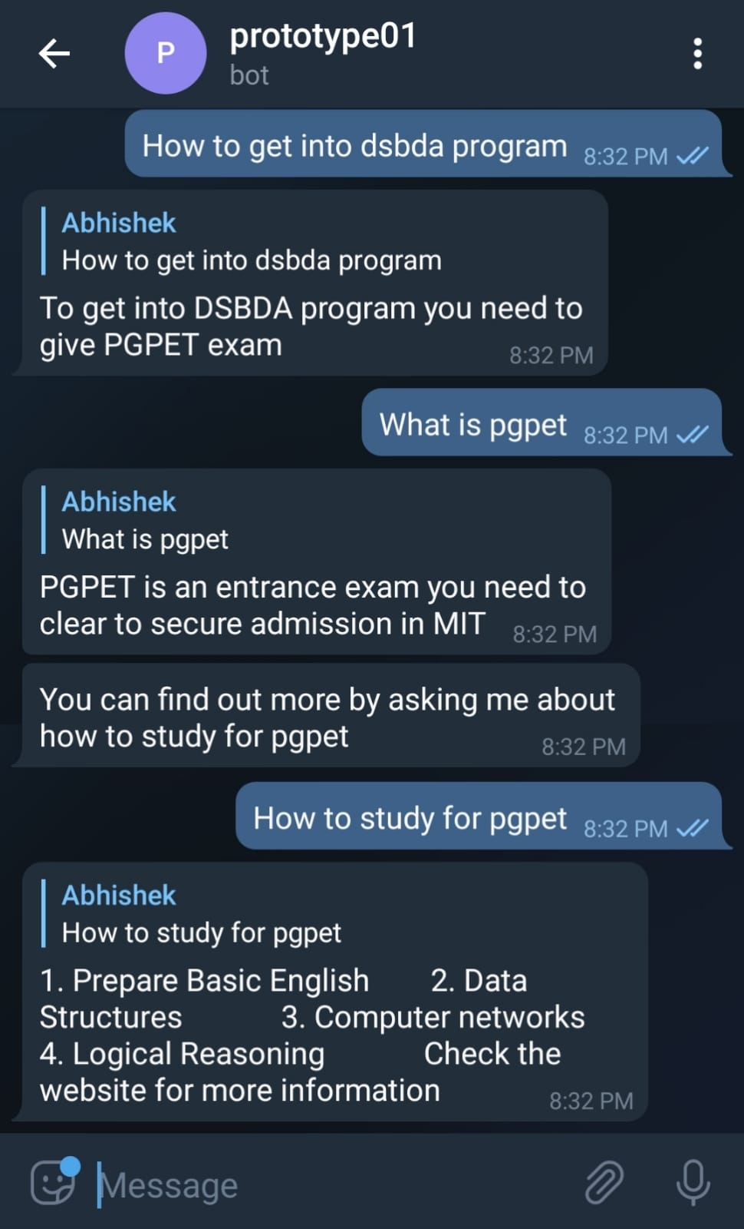

Coded Replies:

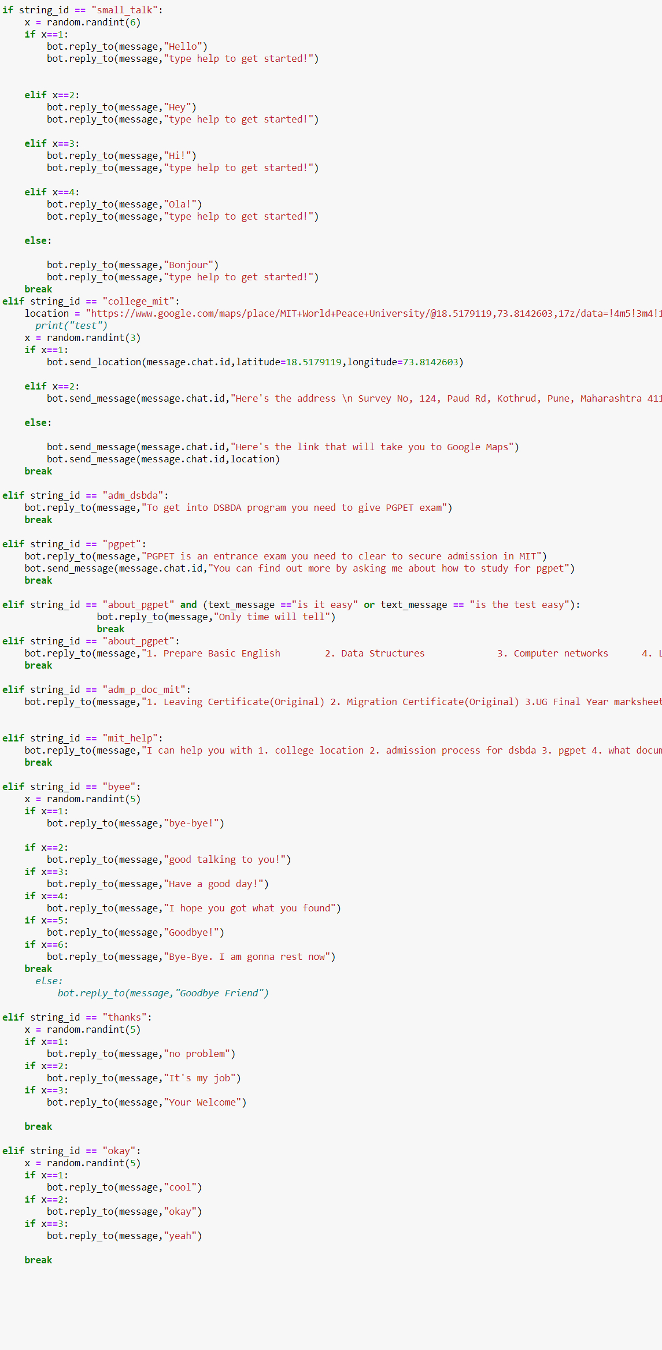

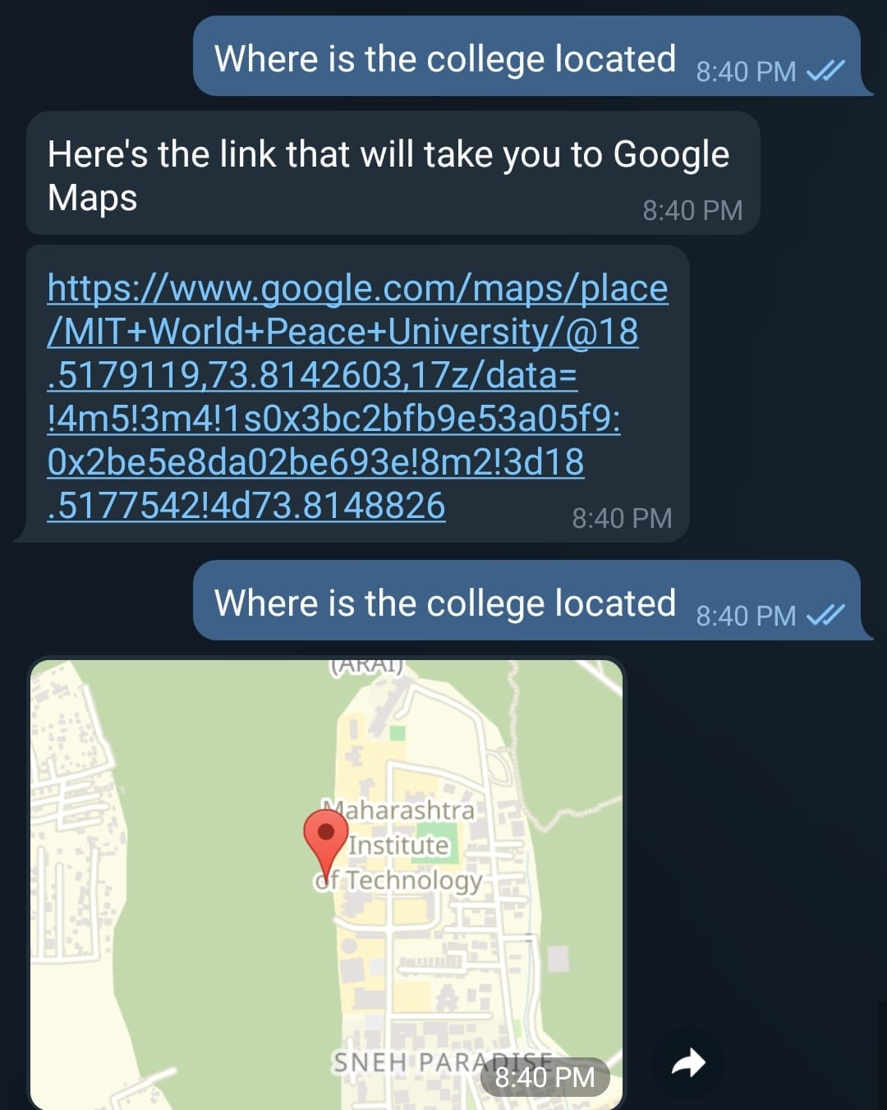The replies are also randomized wherever it is possible.

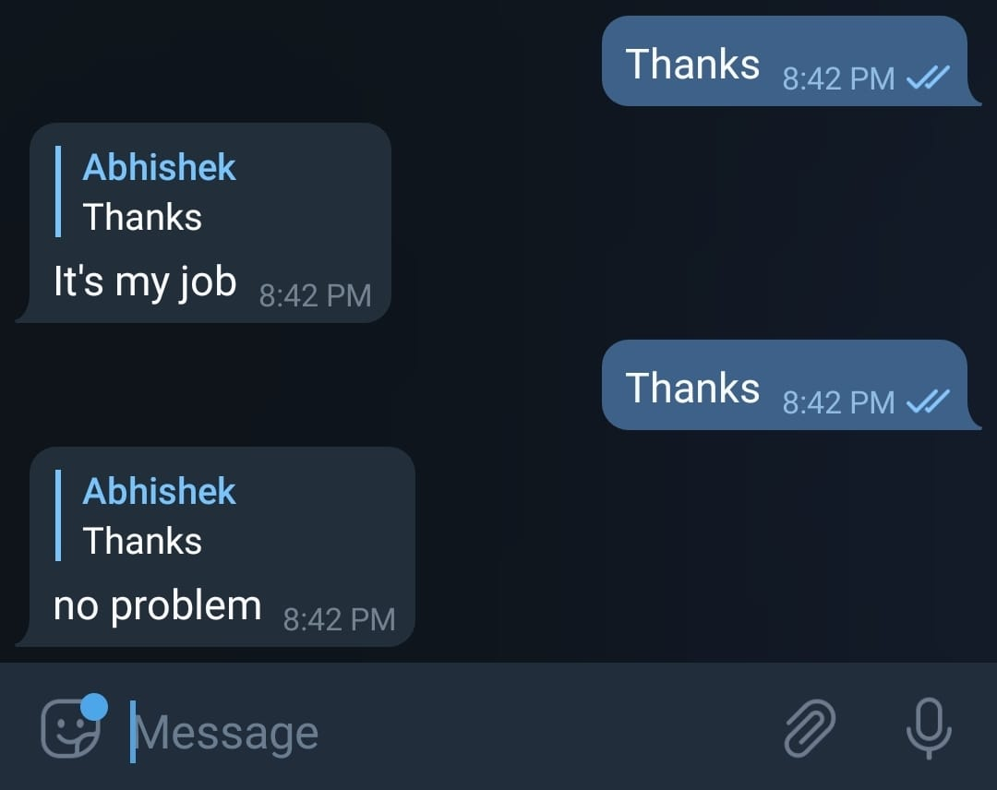

In order to improve our intents and make the bot better , we have also added a logger. It logs the data such as userid , user_firstname , user_lastname , the message sent by the user , date and time the message was sent.

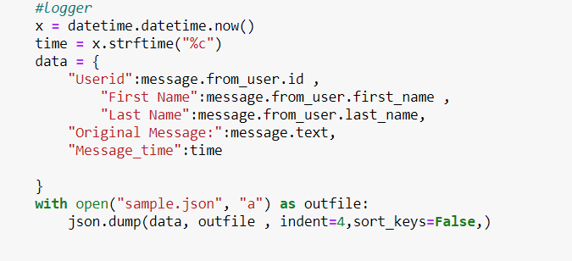

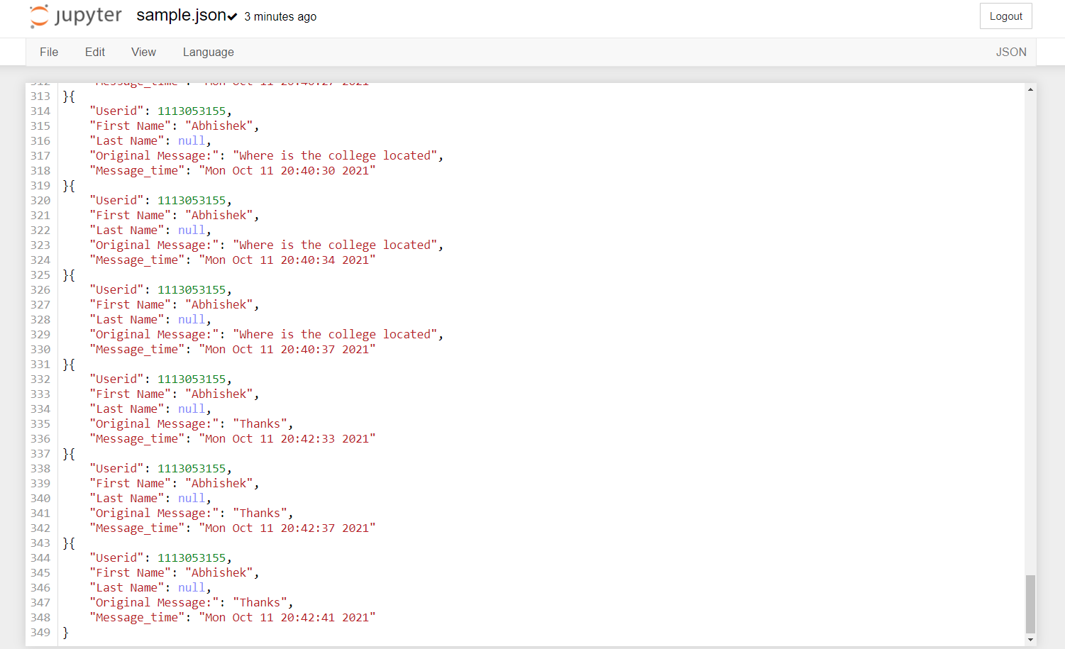

The bot doesn’t only reply to messages, but the bot can also push new messages to the users (who have interacted with the bot at least once).

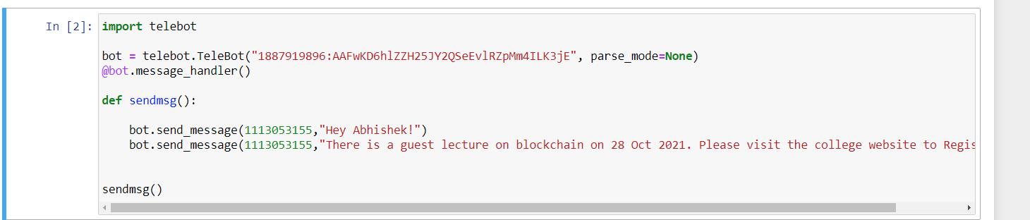

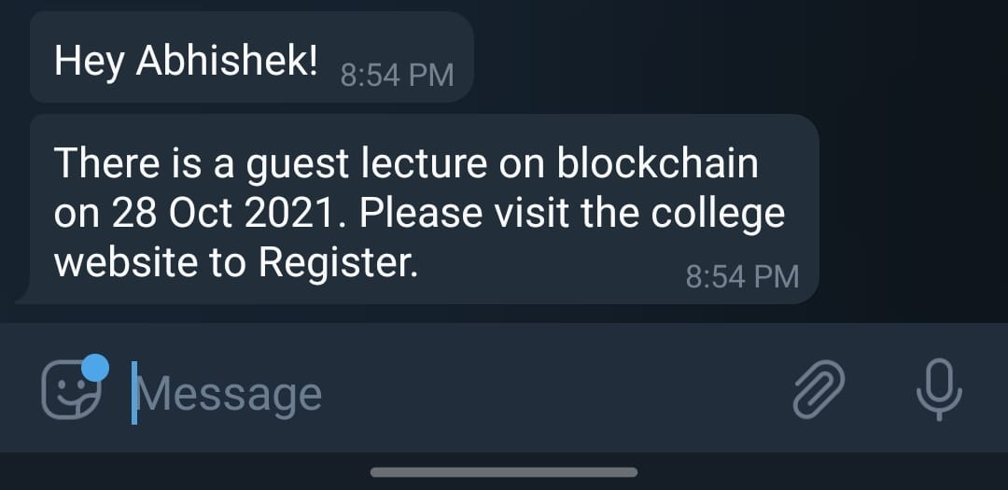

CONCLUSION AND FUTURE WORK

LIMITATIONS

The chat bot is in its early stages so it has a few limitations. It doesn’t understand the context. Users shouldn’t use question marks. Also users should ask questions which are related to the college and admission process only (domain specific).

CONCLUSION

Human language can be transformed into the data transformation with the help of NLP. Natural language processing helps computers communicate with humans in their own language. In this project we made a college specific chatbot system that is custom fitted to education and college based domain chatbot. Each student or

user needs suitable answers and so intents are used to so that purpose can be solved. The primary point here is that bot can help student or user

to get appropriate information about college and course.

FUTURE WORK

The chat bot is its early stages so to say now , right now it works only on intents, but the bot can be improved by Syntactic analysis using POS tagging or shallow Parsing, Lemmatization, Named Entity Recognition. After that Semantic analysis, Text classification can be applied too. Also the project could be deployed on a cloud platform so that the chat bot is active 24/7.

REFERENCES

1. https://towardsdatascience.com/a-simple-chatbot-in-python-with-deep-learning-3e8669997758
2. <https://spacy.io/usage/spacy-101>
3. <https://www.analyticsvidhya.com/blog/2021/07/build-a-simple-chatbot-using-python-and-nltk/>
4. <https://core.telegram.org/bots/api>
5. <https://pypi.org/project/pyTelegramBotAPI>